
Project Charter: [Implement a digital menu and point of sale]

DATE: [12/24/2025]

Project Summary
This project will be focus on integrate tablet system located at each table to offer guests a seamless ordering experience, at the same time provide the restaurant with a more effective ticketing system, and decreasing guest wait time.

Project Goals
- Make fresh, quick food for the working families of our community
- Prioritize our customer needs and wants
- Run an efficient, profitable business model so we can continue to grow in our community
- Support local businesses through our sourcing and partnerships
- Trying to raise the average check total

Deliverables
- Digital menu System implemented
- Tablet_based POS System installed and configured
- Pilot program completed and evaluated
- Staff Training materials and delivered
- Training session complemented
- Operational workflow documentation
- KPI performance report (waste, table turn time, guest count)
- Implement menu tablets by the start of Q2
- Increase appetizers sales by the end of Q2

Scope and Exclusion
In-Scope:
- implementing a digital menu and point-of-sale
- integrate tablet system
- Provide effective ticketing system
- Implemeting initiative and processes aimed at reducing food waste by 25%
- Achieve a 15% improvement in overall production mix efficiency
- Introduce process and improvements aimed at increasing daily guest counts by 10% selling more appetizers and beverages, resulting in increased profits having an average check total to $75 by the end of Q2
- Decrease average turn time by 30 minutes, resulting in decreased customer wait time and more profit
Out-of-Scope:
- Pen orders
- food waste
- 90 minutes average turn time locations
- Adjust policy on orders return

Benefits & Costs
Benefits:
- By including order accuracy and providing better data visibility the project will support informed decision- making regarding the return policy, balancing customer satisfaction and operationa costs.
- The tablets will, provide the restaurant with clear data points on customer ordering and an integrated point of sale system to help guide decision-making in the future
- Success will defined by higher customer satisfaction levels, reduced order-related issues for employees, and improved consistency and organization in operational processes.
- The project will deliver operational clarity by standardiziong order management processes, ensuring alignments between the online ordering sytem and internal policies.
- Key outcomes include significant reduction in order errors, improved kitchen organization and operational flow, a 10% increase in avarage customer spending, and a reduction in avarage table time from 90 minutes to 30 minutes.

Costs:
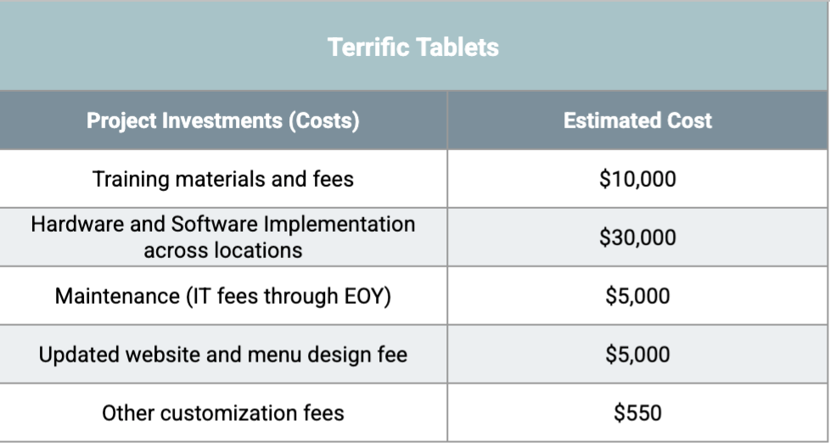

Appendix:
Misalignment 1: GUEST WAIT TIME VS STAFFING COSTS
Stakeholders disagree on how to reduce guestwait time. Some prefer improving processes through technology, othersbelive hiring additionalstuff (bussers, runners.kitchen stuff) is necessary, which my increase labor costs
ACTION TO ADDRESS THE MISALIGNMENT
- Implement the digital menu and POS system to improve order flow and kitchen efficiency
- Review performance data after the pilot. If wait time doesn’t decrease by at least 30%,limited additional staffing will be approved
MISALIGNMENT 2: WASTE REDUCTION VS MENU FLEXIBILITY
Some stakeholders are concerned that reducing food waste by 25% could limit menu flexibility and negatively impact customer satisfaction.
MISALIGNEMENT 3: Adjusting policy on order returns

Stakeholders disagree on adjusting the policy on order returns. Stakeholders concernes includes customers not having a good experience and felling fact-check them, however they prefere discuss about this topic separately to the project

ACTION TO ADRESS THE MISALIGNENTS:
- Discuss separately about the policy on order return
- Review if the policy should be tiied to this project

MISALIGNEMENT 4: HIRING MORE KITCHEN STAFF

Revise the food waste goal to include metrics that better capture carter’s staff performance having the policy tied to this project

MISALIGNMENT 5: IMPROVING THE SATISFACTION OF KITCHEN STAFF

Employee tourover has been high in the last period. Stakeholders concerns are the satisfaction of their employees

ACTION TO ADRESS THIS MISALIGNMENT:
- Discussing about employee satisfaction without having a specific goal yet

